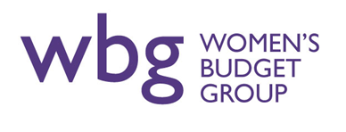

Application for employment as:
Public Affairs Officer
Closing date: 9am Monday 22nd February 2021
Interviews to be held on: Tuesday 9th March 2021
Please answer the questions on the form below, expanding the boxes or using supplementary sheets if required, and sign the declaration at the end.
Please send the completed form to recruitment@wbg.org.uk
Please title your email Public Affairs Officer Application

Family name: First names:
Address:

Preferred telephone:
Email:
Please set out how you meet the requirements of the person specification in the boxes below:
Political advocacy

Organisational skills

Communication skills

Commitment to aims of WBG

Interpersonal skills

Employment History
Please list your previous employment history and work experience relevant to this post
Date | Name and address of Employer | Position and key tasks

Qualifications, education and training
Please list your qualifications, education and training relevant to this post

Statement in support of your application
Please describe the skills, knowledge and experience you have acquired that will enable you to carry out the duties of this post and meet the requirements of the person specification.

If you consider yourself to have a disability please tell us if there are any reasonable adjustments we can make to assist you in your application or with our recruitment process

Do you need a work permit to work in the UK?

When can you start work for us?

Flexible working

Please indicate below if you would like to take up this post as a job-share or would like flexible working arrangements

References
Please give the names and addresses of two persons as referees - other than relatives - who we can approach for references. We may contact referees if you are shortlisted to interview. Please indicate if you do not want us to make contact with a referee prior to interview.

I confirm that to the best of my knowledge the above information is correct.
Signature:
Date:
Please send the completed form to recruitment@wbg.org.uk by 9.00am on Monday 22nd February 2021. Please title your email Public Affairs Officer Application
Interviews to be held on Tuesday 9th March 2021
In line with GDPR legislation, we will only keep application and recruitment records on file for 6-12 months, then dispose of them securely. You may request a copy of any information the organisation holds about you during this time.

